Control Systems Lab

Lab 2 Submission
In this lab, you experimentally determine the parameters in the DC motor transfer function in two ways:
- “Black Box model”: Calculate K and τ directly from the step response
- “Physics-based model”: Calculate K and τ using physical parameter values measured from the motor (e.g. resistance, back EMF, etc.)

Part 1: Black Box method

- Plot the step response from the data that you saved, similar to what you submitted in class. Using Data Tips clearly mark the points you will use to calculate K and $τ$:
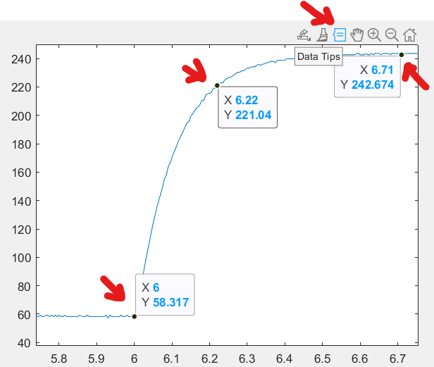
Figure 1: Example step response with marked data points
Clearly label the plot as directed in the course syllabus.

- Using the step response and the data points marked in your graph above, calculate the steady state gain, K, and the time constant, τ . Show your work, including calculations that use the data points above (you must use your marked data points to receive credit).

- Why do we analyze a step that goes from one NON-ZERO speed to another?

Part 2: Physics-based method

- Tables and Calculations for $R$ and$K_{b}:$ Copy you InClass tables for the calculation for $R$ and $K_{b}$ here:
Inclass table with voltages and current for R calculation
Inclass table with voltage, current and velocity for Kb calculation

- Estimating b: Recall that in class you already estimated R and k_{b}. If a DC motor system has relatively small losses, we can assume conservation of energy, meaning that k_{t} = k_{b}. Assuming that is the case for your DC motor system:

  - Write down the steady-state mechanical subsystem equation for a REAL motor (review in-class notes).

  - Create a properly labeled plot of k_{t}*I vs. w using the data points of current and speed measurements in the last experiment of the in-class assignment.
Plot

  - Considering the equation in part a., describe in words how you would estimate $b$ from the plotted data if the constant term is unknown (hint: consider the equation for a line, $y=mx+c$)?

  - Estimate $b$ from the data

- Starting with the electrical and mechanical ODEs for a DC motor system, derive the equation for the Time Constant, $τ$ (s) and the Steady State Gain, K (rad/V.s) in terms of the physical motor parameters. Show your work:

- Calculate the system Time Constant, $τ$ (s) and the Steady State Gain, K (rad/V.s) for the DC motor using the motor parameters that have been obtained. (use $J_{eq}=2.28 e-6$).

- Calculate the system Time Constant, $τ$ (s) and the Steady State Gain, K (rad/V.s) again, but assuming b = 0.

- Is it reasonable to neglect b (discuss your answer in quantitative terms – in this question, credit will be based on the justification for your yes/no answer rather than the answer itself)?

Part 3: Comparison and Conclusions

- Using the sample code below (copy and paste), you can simulate a step response of a first order system with the K and τ .

s = tf('s'); % define Laplace variable
G = K/(tau*s+1); % define 1st order transfer function
[y, t] = step(100*G); % simulate the step response, y(t)
% with input step magnitude of 100
plot(t,y) % plot the output

Plot the simulated responses using K and τ from both the “Black Box” and the “Physics-based” approaches. Plot these simulated responses on top of the experimental data (Hints: don’t forget to account for the non-zero initial conditions; you will have to shift the data accordingly. The MATLAB command ‘hold on’ will be useful). Paste the plot with all three curves here, including appropriate labels and legend.

Plot of experimental data and simulated step responses from Black Box model and the Physics Based mode

Include a screenshot of your entire plotting codel

- Fill in the table below the steady state gain and time constant for each method (include units):

 | Steady State Gain | Time Constant
Black Box
Physics Based
Percent Difference

- Relative to the experimental data, what are possible reasons (at least two) that one approach might be less accurate than the other?

